**Datalogger AirCore RUG**

The data logger is designed and made in-house at the Center for Isotope Research of the University of Groningen to ease the use of our AirCore system. It logs temperature, pressure, and GPS information, and controls an automatic valve through a digital I/O. The data logger is based on the Arduino Nano, and collects data during AirCore flight onto a micro SD card.

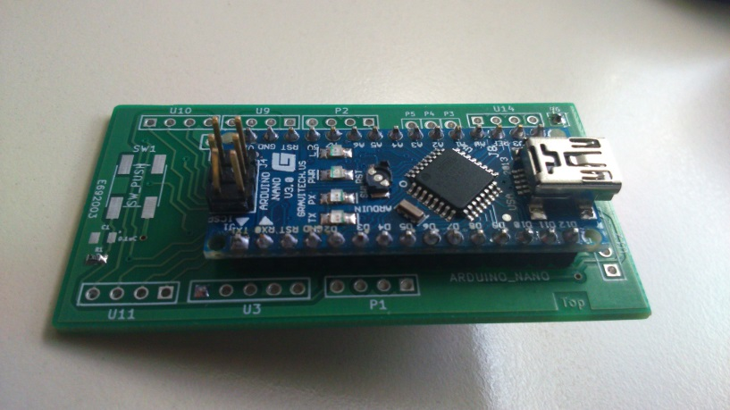

*Figuur 1 Datalogger AirCore*

The data logger functions in a number of ways during flight:

1. Sending a signal to the automatic valve to close the open end of the AirCore shortly (~10 seconds) after landing, shown in figure 6, described in the section below. The data logger uses the pressure measurement or/and GPS location to determine when to send the valve-closing signal. Both can be used, for the Pressure measurement, a pressure sensor is placed on the board. And for the GPS, an external connection is made for connecting the GPS module. The GPS module can also be used for logging the Position of the AirCore.
2. Logging temperatures of the AirCore at up to 6 different places. To know when the measurement has been done, there is a real time clock on board. This clock will give the date and time, which can be programmed.
3. There are also possibilities to connect devices on a I2C bus or SPI bus (max. 3). If the three digital I/O pin aren’t used for the SPI bus, then these pins can be used as digital I/O pin. For example: to give a pulse to activate the automatic valve. When the I²C connection is not used, then these two pins can be used as analog I/O pins. The board has also an extra three analog I/O pins for reading or writing an analog signal. For example to activate a radiometrix.

**- - Bottom of the D.A.R. - -**

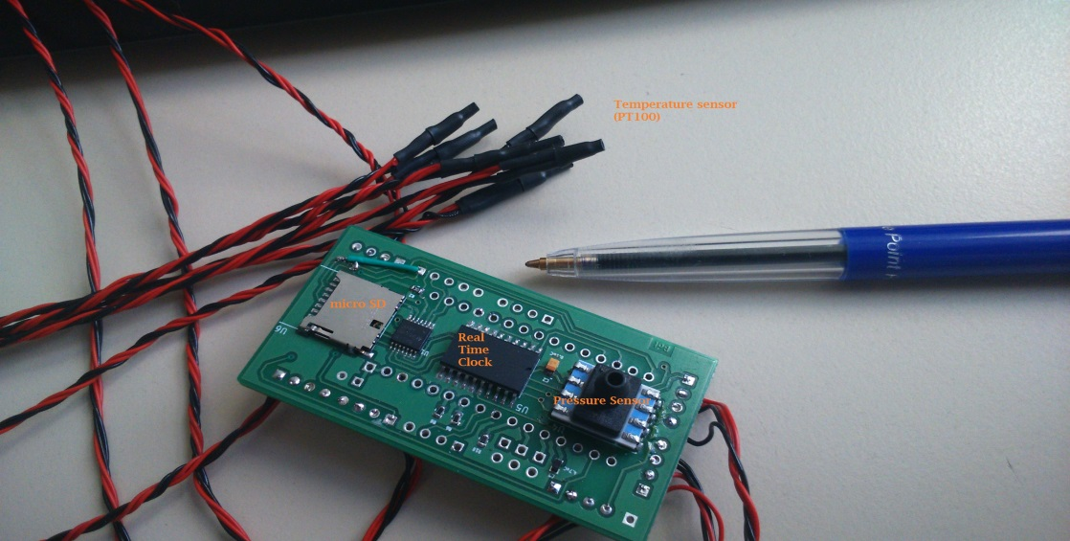

*Figuur 2 Bottom of datalogger*

**Real time measurement.**

The time measurement is done with the real time IC DS3234 from Dallas semiconductors. The IC is an extremely accurate SPI bus RTC. The IC will be communicated and programmed through SPI bus with the Arduino. The time and date will be logged : DD-MM-YY HH:MM:SS.

**Pressure measurements.**

The Pressure measurement is done with the Honeywell TruStability HSC Silicon Pressure Sensor. Pressure sensor is used for detecting landing and communicated with PSI bus. Accuracy ±0.25% and pressure range 0-15 PSI.

**Micro SD card.**

The data will be logged on a micro SD card. The communication is done with the SPI bus.

**Battery**

The datalogger can be supplied by a dc power supply from 6 till 20 volts. The type of battery is depending on the use for the datalogger. For an aircoir flight, the power supply is a 9 volt battery, that is also used for the automatic value.

**- - Top of the D.A.R - -**

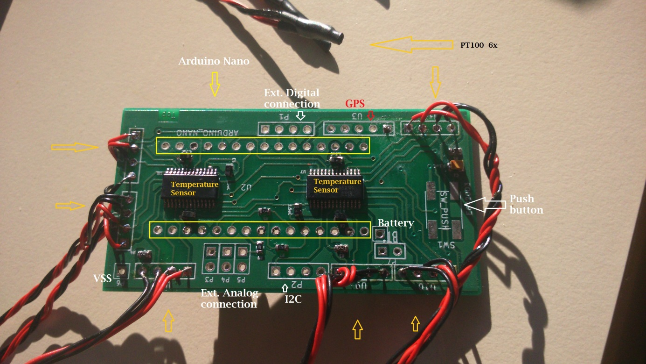

*Figuur 3 Top of the datalogger*

**Temperature measurement.**

The temperature measurement is done with the IC ADS1248, 24-bit Analog-to-Digital Converters for Temperature Sensors. There are 6 places on the board to connect a PT100 sensor to measure the coil temperature. The measurement is done by a three (four) point measurement, because of this method, there can only be 3 sensors on one IC. For 6 sensors, there are two IC on board. The communication of the IC is done with the SPI bus. The sensor is the world´s smallest platinum thin-film temperature sensor from Innovative Sensor Technology. Tolerance class A (0. 15°C)

**GPS connection**

The GSP sensor can be connected to P1, the serial bus connection of the board.

**Ext. I**²**C connection.**

Several devices, that communicate with an I²C bus can be connected to P2. P2 is an I²C bus connection.

**Ext. connection**

There are three analog connection (P3, P4 and P5) on the board, they can be used as analog input or output. 10 bit resolution.

On the board are also three digital i/o connection (P1). These pins can be used for extra connections on the SPI bus, active the automatic value with one external interrupt or input ready sensor.

SW-Push is space for a push button, this can be used for example to activate the data logger.

**Automatic value**

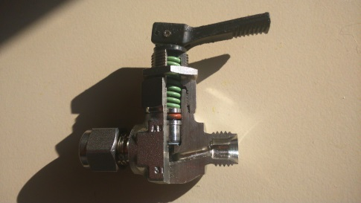

*Figuur 4 Open value*

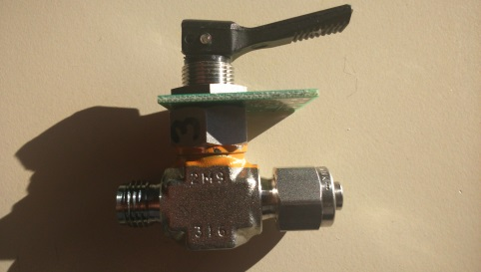

*Figuur 5 Valve: closed*

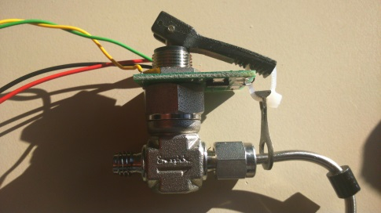

*Figuur 6 Valve: open*

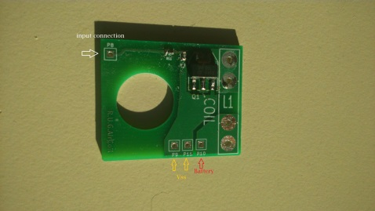

*Figuur 7 PCB of the automatic valve*

The board for the automatic value is based on a 9 Volt battery and a digital input. The automatic value used about 1A for a few seconds, depending of the thickness of the cable tie.